**Create pipeline for DLT**

* To create a pipeline, first we need to create a Databricks work space with premium resource.

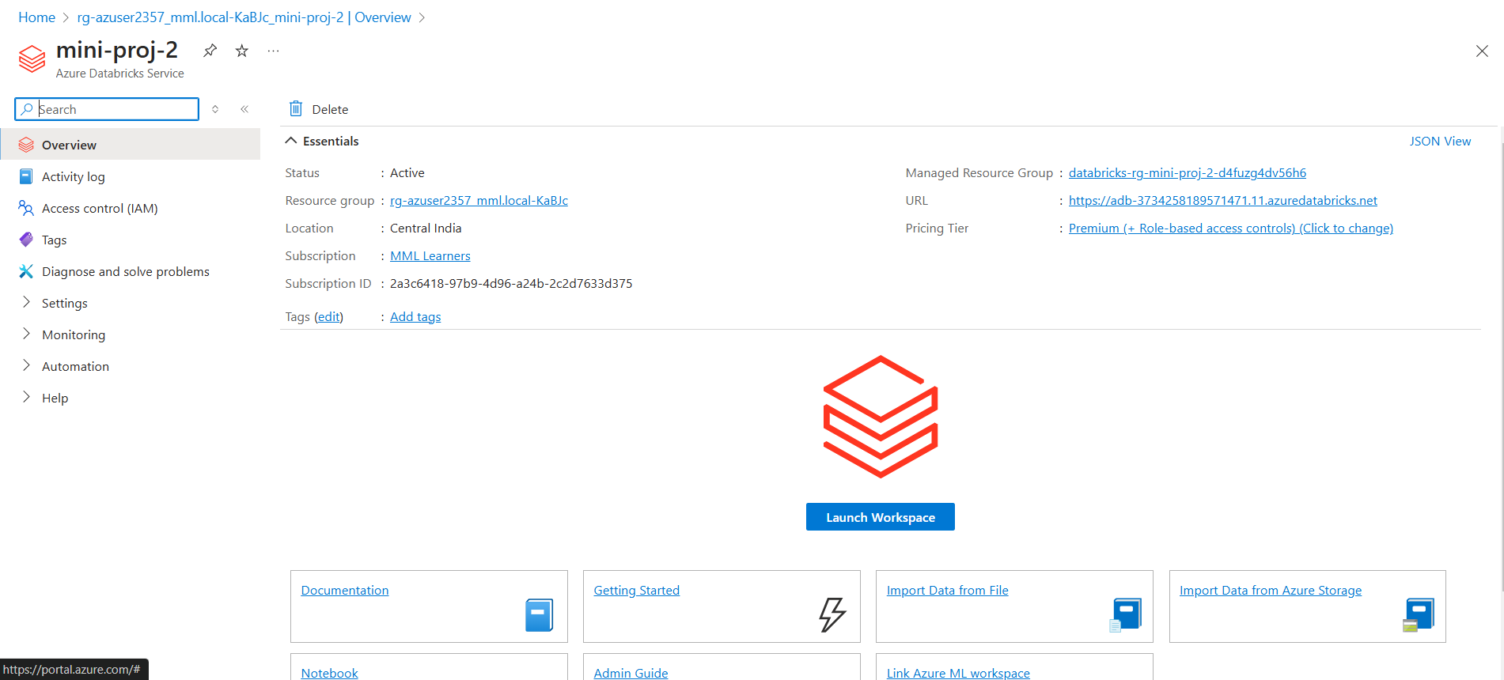

* Once the work space is launched , Under Workflow, click the Delta live tables.

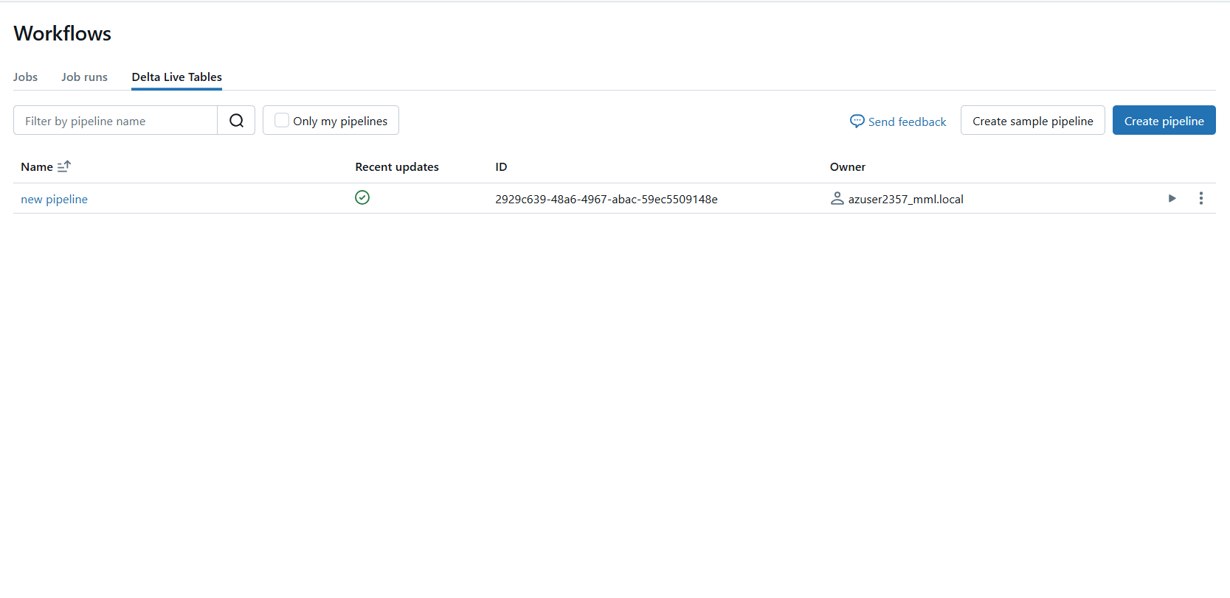

* Click on Create pipeline and create a new pipeline , with the name ,number of worker nodes and etc

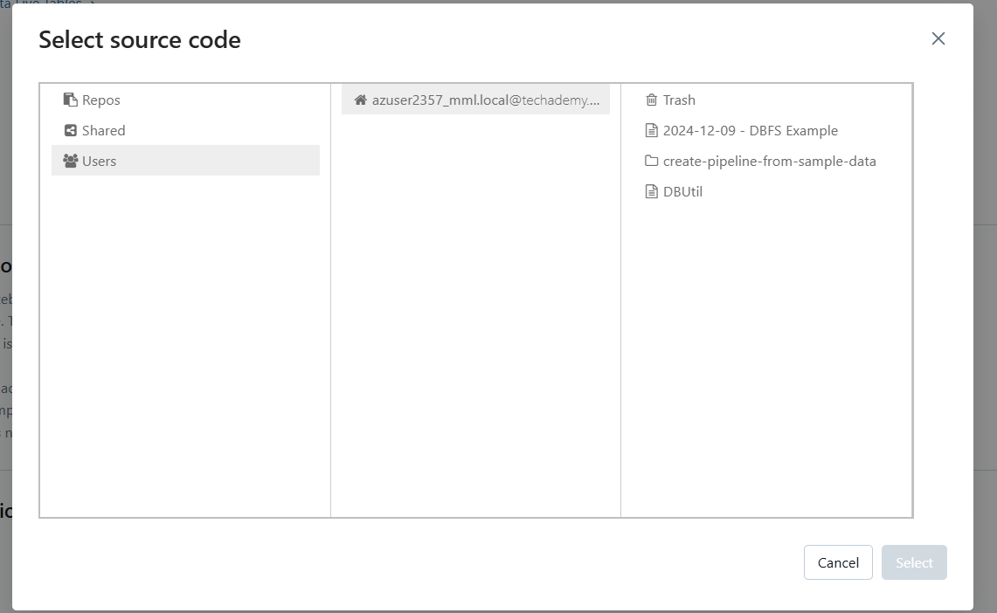

* After creating the pipeline , click on start button to start the workflow

